Bubble sort in C to arrange numbers in ascending order, you can modify it for descending order and can also sort strings. The bubble sort algorithm isn't efficient as its average-case complexity is O(n²) and worst-case complexity is O(n²). There are many fast sorting algorithms like Quicksort, heap-sort, and others. Sorting simplifies problem-solving in computer programming.
Bubble sort program in C
/* Bubble sort code */
#include <stdio.h>
int main()
{
int array[100], n, c, d, swap;
printf("Enter number of elements\n");
scanf("%d", &n);
printf("Enter %d integers\n", n);
for (c = 0; c < n; c++)
scanf("%d", &array[c]);
for (c = 0 ; c < n - 1; c++)
{
for (d = 0 ; d < n - c - 1; d++)
{
if (array[d] > array[d+1]) /* For decreasing order use < */
{
swap = array[d];
array[d] = array[d+1];
array[d+1] = swap;
}
}
}
printf("Sorted list in ascending order:\n");
for (c = 0; c < n; c++)
printf("%d\n", array[c]);
return 0;
}
How Data Structure Bubble Sort Algorithm Works?
An unsorted array is taken as an example. Bubble sort takes Ο(n2) time so keep it short and precise.
Bubble sort starts with very first two elements, comparing them to check which one is greater.
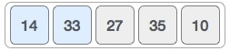
In this case, value 33 is greater than 14, so it is already in sorted locations. Next, compare 33 with 27.
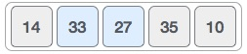
It is found that 27 is smaller than 33 and these two values must be swapped.
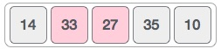
The new array should look like this −
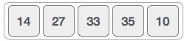
Next compare 33 and 35. It is found that both are in already sorted positions.
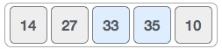
Then move to the next two values, 35 and 10.
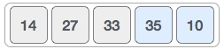
Since 10 is smaller 35, they are not sorted.
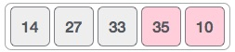
These values are swapped. It is identified that end of the array is reached. After one iteration, the array look like -
1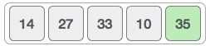
To be precise, now it is showed how an array should look like after each iteration. After the second iteration, it should look like this −
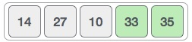
Notice that after each iteration, at least one value moves at the end.
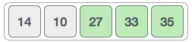
And when there's no swap required, bubble sorts learns that an array is completely sorted.
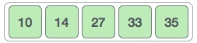
Algorithm
It is assumed that the list is an array of n elements. Further assumed that swap function swaps the values of the given array elements.
Step 1-begin BubbleSort(list)
Step 2-for all elements of list
Step 3-if list[i] > list[i+1]
Step 4-swap(list[i], list[i+1])
Step 5-end if
Step 6-end for
Step 7-return list
Step 8-end BubbleSort

